**Project Development Phase**

**Model Performance Test**

|  |  |
| --- | --- |
| Date | 10 November 2022 |
| Team ID | PNT2022TMID08602 |
| Project Name | Fertilizer Recommendation System For Disease Prediction |
| Maximum Marks | 10 Marks |

**Model Performance Testing:**

Project team shall fill the following information in model performance testing template.

|  |  |  |  |
| --- | --- | --- | --- |
| **S.No.** | **Parameter** | **Values** | **Screenshot** |
|  | Model Summary | Total params: 38,160,755  Trainable params: 38,160,755  Non-Trainable params: 0 |  |
|  | Accuracy | Training Accuracy – 97.55  Validation Accuracy – 96.45 |  |

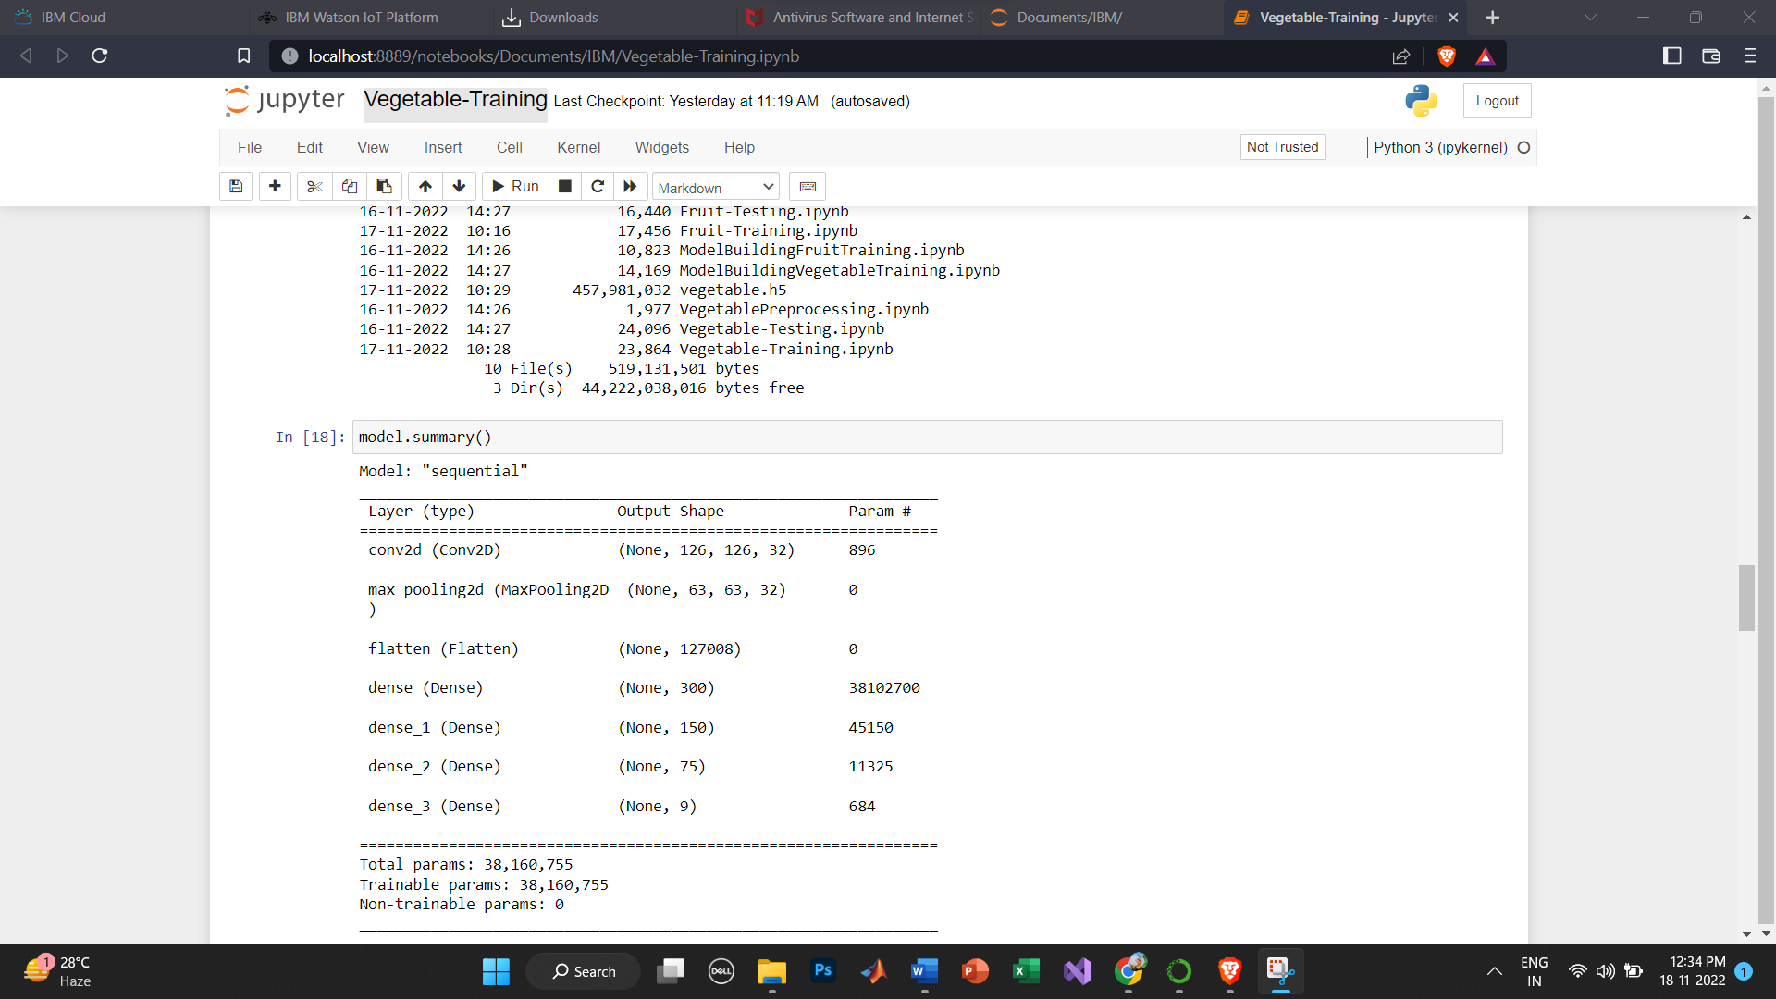**MODEL SUMMARY:**

**ACCURACY**:

